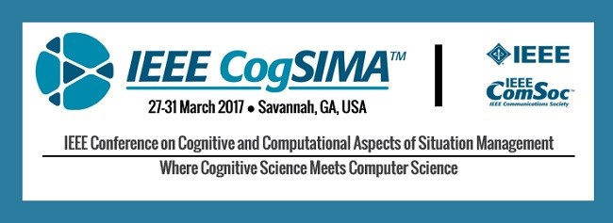
IEEE CogSIMA 2017 will provide a venue for presenting multidisciplinary research on complex heterogeneous systems of interacting humans, machines, computer agents and/or networks.

Submissions should address cognitive and/or computational aspects of situation management, which is the synergistic goal-directed process of situation awareness and control in dynamic systems so that desired goal situations are reached within predefined quality, resources and time.

Areas of possible interest include:
- Big Data, Deep Learning, and Situation Awareness
- Cognitive Modeling and Decision Support
- Interaction with Autonomous Systems
- and Others...
IEEE CogSIMA conferences are aimed at researchers and practitioners from academia, industry and government, with a wide variety of backgrounds and experience including computer science, human factors, cognitive science, modeling & simulation, robotics, and systems engineering.

Paper submissions are due 23 November 2016

http://ieee-cogsima.org

